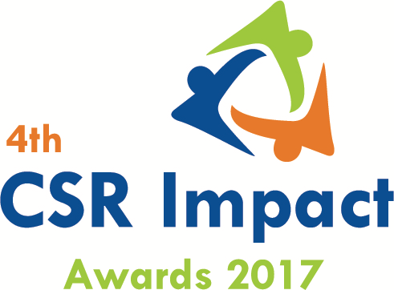

Applying as
CSR Funding Agency
CSR Implementing Agency

4th CSR Impact Awards 2017-Application Form (Category 12)

Please select the Category (Only one category/each form, for more than one category submit separate form and read the guidelines)
Category
12 | CSR Foundation of the Year 2016-17 (only for CSR Foundation)

(Please read the award-guidelines carefully before submitting this form)
Please send filled in form and application fee to the address below and email a copy to bhomik@ngobox.org and ngobox2012@gmail.com

NGOBOX (Renalysis Consultants Pvt Ltd)
A2/610, Palladium, Corporate Road (300m from Vodafone House), Prahlad Nagar,
Ahmedabad 380051 (Gujarat)
Call +91-9560352170

Please provide the application fee information here
Application Fee: INR
Paid vide Cheque/DD/NEFT:
Date:
Comment:

Date: Location:

Part A: Organizational Profile

A1 | Name of the organization applying for the Award (Full Name) (Please do not use acronym)
A2 | Office Address | Address:  Contact No.
A3 | Contact Person for this application (This will be the nodal contact point for this application) | Name:  Designation:  Mobile:  Email:  Alternate Contact no.
A4 | Organization website
A5 | Type of organization | CSR Foundation/Trust
A6 | Name of the CEO/President/Director
A7 | By submitting this application form, the organization agrees to provide all the project related information during the assessment process and will abide by the rules set by the organizers. The applicant also acknowledges that all the information provided in this application form is correct.
 | Seal, Name and Signature of Authorized Representative

Part B: Project & Programme Details

Give a brief introduction of the organization (200 words)
What are the main CSR focus areas of the organization
States/geographic description of the operations of the organization
Does the organization implement CSR projects on its own or through other implementing partners
What was the annual CSR budget of the foundation in FY 2016-17 (INR)s

Part C: Projects & programme Summary
C.1. Enlist 3-4 flagship programmes of the foundations.
S.no. | Programme/Projects | Geographic coverage

C.2. Briefly describe three main programmes of the foundation with focus on programme objectives, operations plan, partners, geographic coverage, resource usage, monitoring and impacts. (500 words for each programme)

Part D.1: How has the foundation identified CSR projects need and beneficiaries? (300 words)

Part D.2: How has the foundation being innovative in CSR planning, projects implementation and monitoring of the projects? What have been impediments in the CSR projects/programme management at the grass-root level. (700 words)

Part D.3: How has the organization tried to leverage its expertise and scale up the operations? (400 words)

Part D.4: What have been the major achievements of the foundation in FY 2016-17? (500 words)

Part E: Why do you think that the Foundation should be considered for the ‘CSR Foundation of the Year 2016-17’? (600 words)

q
Annexure
- Please add appropriate annexure like tables, images, diagrams, media-reports, web-links). In case you wish to submit a Power point presentation for the project, please send the same along with the application. The maximum number of slides: 10)
- In case you wish to enclose a report or any other documentary proof, please send the same along with the hard copy of the application form and mention the same here.

__***___

