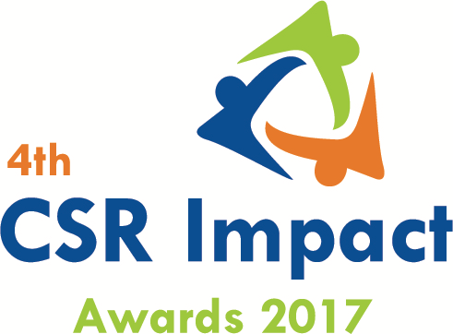

4thCSR Impact Awards 2017-Application Form (Category 14)

Please select the Category(Only one category/each form, for more than one category submit separate form and read the guidelines)
Category
14 | CSR Implementing Agency of the Year (2016-17)

(Please read the award-guidelines carefully before submitting this form)
Please send filled in form and application fee to the address below and email a copy to bhomik@ngobox.org and ngobox2012@gmail.com

NGOBOX (Renalysis Consultants Pvt Ltd)
A2/610, Palladium, Corporate Road (300m from Vodafone House), Prahlad Nagar,
Ahmedabad 380051 (Gujarat)
Call +91-9560352170

Please provide the application fee information here
Application Fee: INR
Paid vide Cheque/DD/NEFT:
Date:
Comment:

Date: Location:

Part A: Organizational Profile

A1 | Name of the organization applying for the Award (Full Name) (Please do not use acronym)
A2 | Office Address | Address:  Contact No.
A3 | Contact Person for this application (This will be the nodal contact point for this application) | Name:  Designation:  Mobile:  Email:  Alternate Contact no.
A4 | Organization website
A5 | Type of organization
A6 | Name of the CEO/President/Director
A7 | By submitting this application form, the organization agrees to provide all the project related information during the assessment process and will abide by the rules set by the organizers. The applicant also acknowledges that all the information provided in this application form is correct.
 | Seal, Name and Signature of Authorized Representative

Part B: Project& Programme Details

Give a brief introduction of the organization (200 words)
What are the main CSR Projects & Programmes that the organisation is implementing for last 2 years
States/geographic description of the operations of the organization
Who have been major CSR funding partner for your organization
What was the annual CSR funding received by the organisation in FY 2016-17 (INR)
What was the overall actual CSR spend of the organisation in FY 2016-17)

Part C: Projects & programme Summary
C.1. Enlist flagship CSR programmes implemented by the organisation
S.no. | Programme/Projects | Geographic coverage | CSR project of company | Project budget in FY 2016-17 (INR)

C.2. Briefly describe three main CSR programmes implemented by the organisation with focus on programme objectives, operations plan, partners, geographic coverage, resource usage, monitoring and impacts. (500 words for each programme)

Part D.1: Please describe how all of the above projects were identified and selected for implementation? (400 words)

Part D.2: How were the company and implementing partners innovative in CSR planning, projects implementation and monitoring of the projects? What have been impediments in the CSR projects/programme management at the grass-root level. (700 words)

Part D.3: How did the organization try to leverage its expertise while implementing projects? (400 words)

Part D.4: What have been the major projects achievement since its beginning? (500 words)

Part D.5: What was so specific and outstanding in FY 2016-17 in tram of CSR projects and programmes implemented by your organisation? Please provide major impact matrix along with resources used in each of the project in Fy 2016-17. (700 words)

Part E: Why do you think that the organisation should be selected for the ‘Implementing agency of the year 2016-17? Please provide due justification of the each of the points.

Annexure
- Please add appropriate Annexure like tables, images, diagrams, media-reports, web-links). In case you wish to submit a Power point presentation for the project, please send the same along with the application. The maximum number of slides: 10)
- In case you wish to enclose a report or any other documentary proof, please send the same along with the hard copy of the application form and mention the same here.

__***___

