Request for Proposal
Purpose: Conducting an Impact Assessment study of Tech Mahindra Foundation’s work over past ten years.
Dated: 15 November 2017
Submission Deadline: 30 November 2017
Introduction:

Tech Mahindra Foundation is the Corporate Social Responsibility (CSR) arm of Tech Mahindra. It was set up in 2007 as a Section 25 Company (referred to as Section 8 Company in the Companies Act, 2013), with a vision of Empowerment through Education.
The Foundation’s programmes span twelve locations in India namely – Bengaluru, Bhubaneswar, Chandigarh, Chennai, Delhi-NCR, Hyderabad, Jaipur, Kolkata, Mumbai, Nagpur, Pune and Visakhapatnam. It operates through a New Delhi-based Corporate Office, city-based Chapters and a number of Project Offices.
The Foundation works in three key areas - Education, Employability and Disability. It is currently running 150+ projects with over 100 partners across India. The programmes are run in both direct and partner implementation modes.

With these, the Foundation, has established itself as one of the leading CSRs in the country, reaching out to almost 100,000 primary and 400,000 secondary/tertiary beneficiaries.

Partner Implementation Programmes (PIP):

Education
Tech Mahindra Foundation's overarching goal is 'Empowerment through Education.' It works with Government Primary Schools by supporting initiatives that lead to sustainable transformation. The Education programme works with schools, teachers and the community to impart quality education to children from disadvantaged communities, with a focus on improving learning outcomes.
The Foundation's work in education focuses upon two thematic areas:
ARISE, All Round Improvement in School Education Programme helps children acquire grade-appropriate competencies and helps in all around development of children. It works with Government schools in six states of India.
SHIKSHAANTAR or Teacher Empowerment Programme empowers teachers by building their professional and academic capacities. The In-Service Teacher Development Programmes have benefitted over 26,000 teachers, 1,000+ school management professionals in over 1000 government schools across India.

Employability
The SMART programme began in 2012 with 3 centres and trained 1,000 youth in the first year. Today, the Foundation supports 100 SMART Centres across 11 cities of India, training more than 19,000 youth annually and successfully plugging the demand and supply gap in multiple manufacturing and service industries. 50% of the beneficiaries are women and 10% are young people with disability.
The SMART Vocational Training Programme Includes:
• SMART
• SMART+ (Training for persons with disabilities)
• SMART-T (Training for Technical Trades)
• SMART Academy for Healthcare

The Training Manuals are detailed and easy to comprehend. A robust system of regular assessments and certification on successful completion of the training are an integral part of the programme. Immense importance is given to train the students in soft skills. Youth graduating from SMART centers are successfully placed in the service and manufacturing sectors. The SMART programme has a live Management Information System that helps in monitoring and evaluation of quantitative and qualitative data across all locations.
The Foundation implements the SMART programme through partner NGOs across twelve cities in India. It constantly invests in high-quality training and capacity building of its partners.

Disability
The Foundation works with children and youth with disabilities in the areas of education and skill development. Activities under the disability programme focus on the dignity and independence of persons with disabilities.

Under the ARISE + programme children with disabilities from the under privileged communities are identified, educated and enrolled in mainstream school. Along with this the Foundation also supports regular training for caregivers, awareness and sensitisation programmes on disabilities, rehabilitation requirements such as speech therapy, physical therapy, orientation and mobility training and accessing their rights and entitlements.

The SMART+ programme focuses on providing employable market-related entrepreneurial skills, and opportunities to youth with disabilities. Specially designed curriculum and well-equipped classrooms in the centres allows young people with disabilities to obtain different foundation skills such as Basic IT and Computers, Spoken English and Workplace Readiness.

Direct Implementation Programmes (PIP):

SHIKSHAANTAR
Set up in 2013, the In-Service Teacher Education Institute (ITEI) is a Public Private Partnership Project (PPP) wherein the Foundation has partnered with East Delhi Municipal Corporation (EDMC) to upgrade the skills of government primary school teachers through stringent training process.

The aim of the project is to bring quality enrichment in education by ensuring development of physical and mental abilities of children through capacity enhancement of all stakeholders especially, teachers.

The ITEI has four departments - Hindi, English, Mathematics and EVS and works at both enhancing subject knowledge and pedagogical skills.

The Institute strives to facilitate professional development of over 5600 EDMC teachers, education inspectors, principals, teachers and community members.

Employability
SMART Academies
Launched in May 2016, The first Tech Mahindra SMART Academy is working for training paramedics in Healthcare Sector. The Academy is a state-of-the-art training institute. It aims at creating a cadre of well qualified, trained professionals in the field of allied healthcare by providing high quality innovative and interactive training to young men and women keen to pursue a career in Healthcare. The second SMART Academy also in Healthcare sector has been launched Mohali. The third SMART Academy has been established in Visakhapatnam. This Academy deals with courses in IT and Logistics.

The emphasis at all the Academies is on quality and all round training, which lays the foundation of life-long learning as a powerful way to tap into potential employment opportunities for youth in difficult circumstances. Continuous upgradation, self-improvement and strong processes are part of the Academy’s core philosophy.

The Tech Mahindra SMART Academy for Healthcare offers following courses:
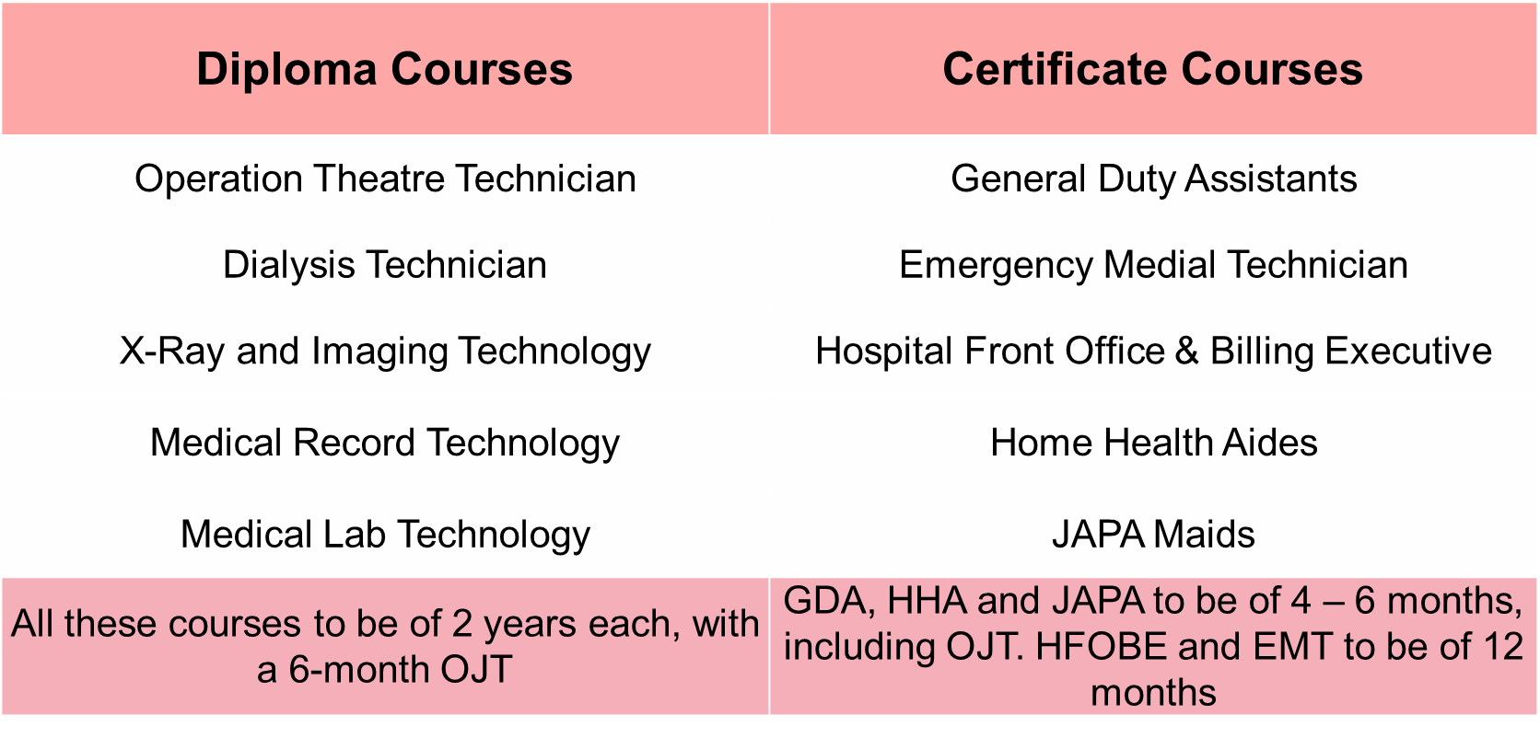

On completion of ten years of existence, the Foundation is inviting proposals for a multi-city Impact Assessment study to highlight the impact of our work in Education and Employability over the years.
Objectives of the Assignment:
- Identify social indicators against which the impact assessment can be done
- Design and develop framework for conducting impact assessment study
- Conduct Impact assessment study.

Scope of work:
Geography: Since the study needs to consider the impact of our work over last several years, the suggested geographies where the study should focus on are Pune, Delhi NCR and Bengaluru.
The detailed scope of the assignment for Conducting Impact Assessment study of Foundation’s work on completion of ten years is outlined as follows:
- Define the parameters for conducting the impact assessment for education and employability projects
- Collect necessary data and information from all the stakeholders
- Data entry and analysis

- Documentation of case studies and stories of change
- Preparation and submission of final report

Timeline:
The study should be completed within a period of 12 Weeks w.e.f. date of the signing of the agreement.

Work Components: Timeline from date of order
Detailed Assessment Framework Two weeks
Research Methodology Three weeks
Draft Report Submission Ten Weeks
Final Report Submission and presentation Twelve Weeks

Terms of payment:
On signing of Agreement 20%
On Submission of Research Methodology 20%
On Submission of Draft Report 40%
On Submission of Final Report 20%

Eligibility Criteria:
- The agency should be working in the social sector for at least 5 years
- The agency should have worked on similar kind of projects at national/international level
- The agency should have sound understanding of national and international sustainable goals

Date and Process of Application
- Interested agencies can submit a detailed proposal by 30th November, 2017 at Sajid.ali1@Techmahindra.com
- The proposal should also include organization profile and team strength.
- The proposal should contain technical and financial components.
- Only shortlisted agencies would be contacted.
- Queries on the RFP will be addressed only through e-mail.

